Doka Powers Safe and Efficient Core Construction at Fan Pier’s One Harbor Shore Drive

Kenilworth, New Jersey | Doka, a global leader in formwork and scaffolding solutions, is setting new benchmarks in safety and efficiency as construction progresses at the highly anticipated 17-story condominium building One Harbor Shore Drive, located within Boston’s iconic Fan Pier development.

The 245,000-square-foot mixed-use building will feature 218,500 sq. ft. of residential space, 23,500 sq. ft. of cultural space, and 3,000 sq. ft. of retail and restaurant offerings, along with approximately 130 residential units, including on-site affordable housing supporting Boston Planning and Development Agency goals.

As construction climbs toward its full 217-foot height, the spotlight is on Doka's custom Shear Wall Climber SCP system, a cutting-edge formwork solution that meets the fast-paced demands of the project while upholding the highest standards of safety.

"When I think about Doka, I'm thinking big, fast, and efficient. With their systems, we can pour a floor a day, jump it, and pour it again the next day. I don't know what's faster than that; Doka makes it work," says Jacob Holt, Carpenter Foreman at G&C Concrete, Inc., the concrete contractor on the project.

Redefining Safe High-Rise Core Construction
The project’s unique core construction presented challenges that Doka addressed through innovative engineering. Doka’s Shear Wall Climber SCP is fully crane-independent, allowing for entire levels of formwork, working platforms, and concrete placing booms to be raised with the push of a button—minimizing crane time and maximizing project speed. Its self-guiding, self-leveling hydraulic cylinders ensure plumb alignment every time, and the 6-foot-wide walkways—wider than conventional systems—improve worker safety and efficiency on site.

Paired with the Shear Wall Climber SCP, Doka’s innovative FormDrive system sets a new industry standard by automating climbing and formwork removal. This next-generation control and drive system allows formwork to be lifted and adjusted at the touch of a button, using a tablet-controlled interface for real-time accuracy and control.

“Doka’s new Shear Wall Climber SCP was a great solution for this project — delivering the speed, safety, and efficiency that a high-profile job like One Harbor Shore Drive demands,” said Michael Kennedy, CEO of Doka USA and Executive Vice President of North America and Latin America. “Our U.S.-based team is proud to have played a lead role in developing and launching this innovative technology with our global colleagues. We are incredibly grateful for the trust and partnership of Turner Construction and G&C Concrete in bringing this system to life on such a landmark project.”

Key features of the Doka system include:
- Flexible forming for cores up to 20 feet high, poured with slabs or ahead of them
- Crane-independent climbing, freeing up critical site resources
- Fast cycling with stripping corners requiring as little as 2 inches of clearance
- Efficient, single-stroke hydraulic operation to raise core formwork and platforms
- Automated climbing and formwork removal with Doka FormDrive, helping teams work faster, safer, and with less manual effort
- High-capacity platforms that double as material storage space
- Permanent locking mechanisms for improved stability in all weather conditions

A Seamless Fit for Boston’s Waterfront Vision
Developed by The Fallon Company, with Turner Construction as general contractor and CBT Architects as designers, the One Harbor Shore Drive on Parcel H will complete the Fan Pier master plan. The structure contributes to Boston’s evolving waterfront skyline with a dynamic mix of luxury residences and public amenities, including the final piece of the Fan Pier Public Realm.

The building’s foundation and underground garage have been in place since 2016, positioning this final phase for timely completion, thanks in part to Doka’s advanced solutions that save time and labor while enhancing safety.
****
In short:
Project Name: One Harbor Shore Drive at Fan Pier
Location: Boston, Massachusetts
Developer: The Fallon Company
General Contractor: Turner Construction Company
Concrete Contractor: G&C Concrete, Inc.
Architect: CBT Architects
Type of structure: Condominium
Height: 217 feet
Stories: 17
Cycle time: 1-2 days
Products used: Framax, Shear Wall Climber SCP, FormDrive

****

About Doka
Doka is a world leader in innovative formwork and scaffolding solutions for construction. With more than 180 sales and logistics facilities in over 58 countries, Doka has a highly skilled, global team that delivers advice, engineering, customer service, and technical support for even the largest and most complex projects. The company's sophisticated distribution network ensures world-class service for customers wherever they work – from the largest cities to the most rural jobsites. Doka employs more than 9,000 people worldwide and is a company of the Umdasch Group, which has stood for reliability, experience, and trustworthiness for more than 150 years.

****

Media contact
Claire Combs
Director of Communications
North America and Latin America
M +1 918 998 3333
claire.combs@doka.com | www.doka.com

****

Photos:
Please include details of copyright for publication.

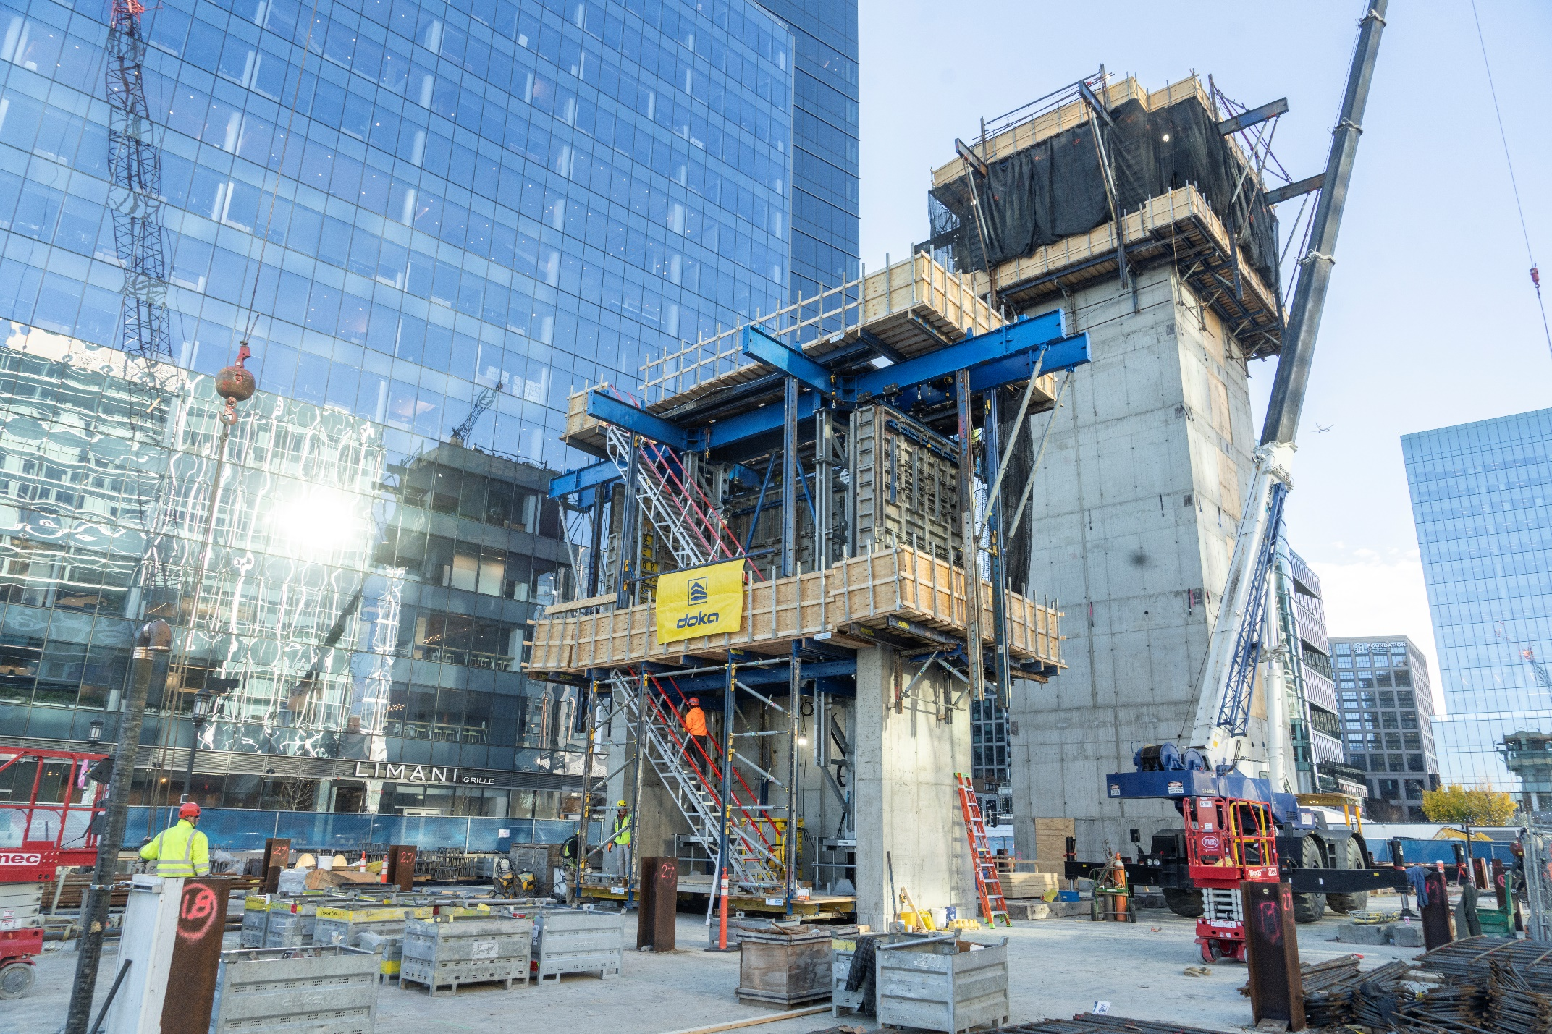
Cores with forming heights of up to 20 feet can be poured with the slabs or climbed ahead of slab pours.
© Doka

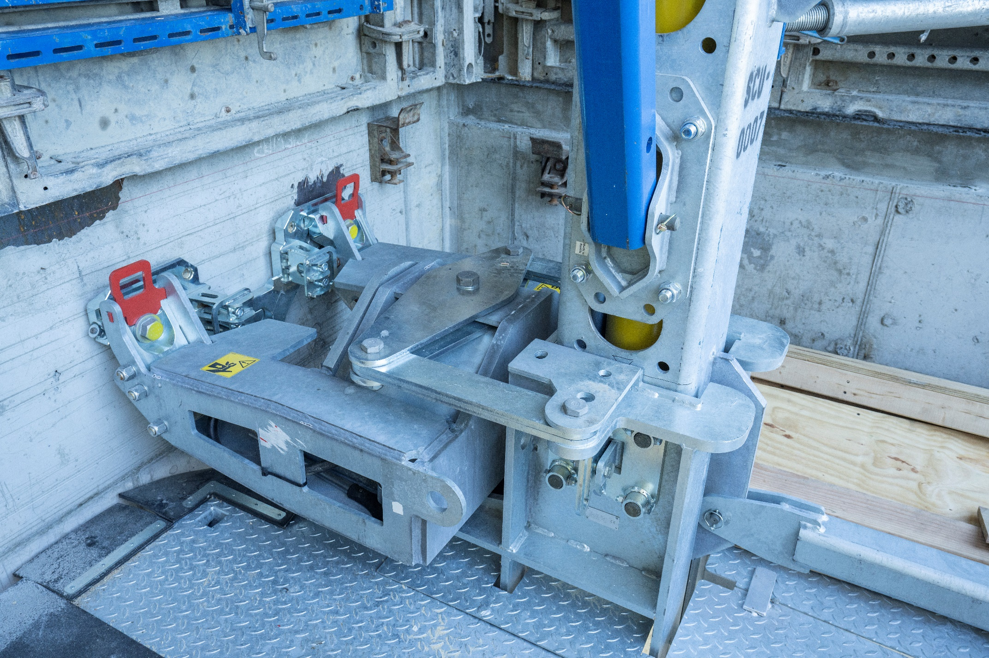
Self-guiding, self-levelling hydraulic cylinders ensure the core remains plumb. Up to 18 climbing brackets can be lifted at one time together from one hydraulic drive unit.
© Doka

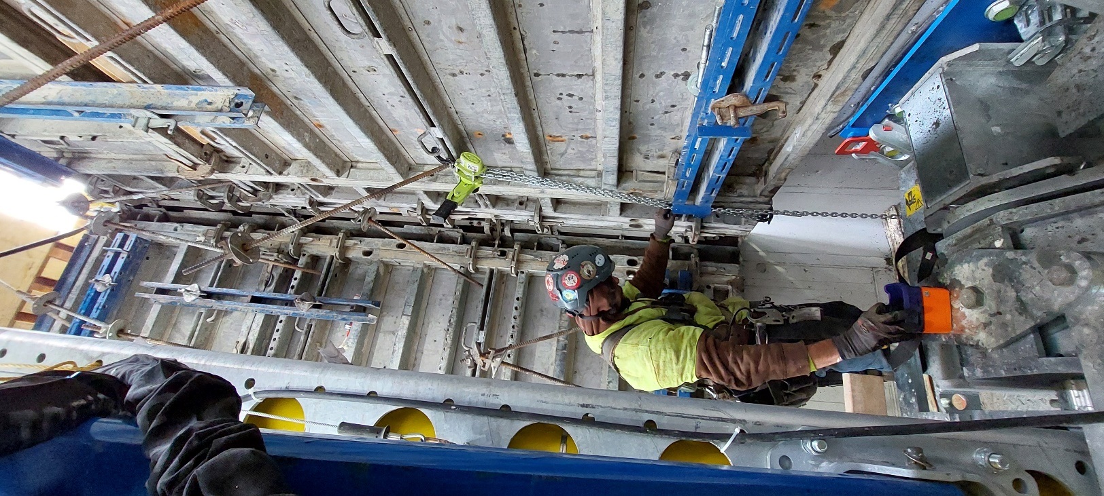
When used in combination with the Doka stripping corner, no breaking or re-connecting gangs are required on the inside core wall formwork.
© Doka


Michael Kennedy, CEO of Doka USA and Executive Vice President of North America and Latin America
© Doka

