**Doka supports infrastructure projects with end-to-end solutions**  
Major UniKit upgrades and more unveiled at bauma 2025

**Kenilworth, New Jersey – Infrastructure construction demands adaptable, high-performing solutions. As a full-service provider for formwork and scaffolding, Doka supports customers with a comprehensive offering that covers all project phases, from engineering and planning to safe and efficient execution on-site. At bauma 2025 in Munich Germany, Doka demonstrated how this integrated approach creates measurable value for modern infrastructure projects worldwide.**

At the heart of Doka’s infrastructure innovation is the enhanced Doka UniKit system, a heavy engineering kit that has already proven its value on complex job sites such as bridges, tunnels, power plants, and large-scale industrial buildings. With its flexible configuration, high load-bearing capacity, and high level of safety, UniKit is now being presented with new applications, which were unveiled to the public for the first time at bauma 2025.

**Stronger and more adaptable**

One of the standout additions is a new wall-mounted support, capable of transferring loads up to 400 kN without support underneath. The solution is rotatable and has low installation height, supporting applications in a wide spectrum, for example, bridge abutments and cut-and-cover tunnels. In addition, the UniKit Shoring Tower 1000 is now compatible with Ringlock Scaffolding. Both can be pre-assembled in horizontal or vertical positions at ground level and lifted into place by crane. This setup increases safety, reduces complexity, and streamlines installation – especially on demanding infrastructure sites.

The full integration of UniKit with Ringlock scaffolding opens up safe vertical access and working platforms even at extreme heights. Combined with enhanced modularity and high load-bearing capacity, the system enables accelerated assembly and high safety standards—ideal for infrastructure and industrial applications. As a result, Doka now offers interface-free solutions for heavy shoring, scaffolding, and safety.

In addition to UniKit, Doka presented several forward-looking innovations tailored to infrastructure needs**:**

**DokaXshore: High-performance shoring, simplified**

DokaXshore is a next-generation shoring system that combines the stability of frames with the geometric adaptability of a multi-directional system. Engineered for streamlined performance, it features just four parts per level, ensuring all-around safety and enabling intuitive, tool-free assembly. With a high-load capacity of 100 kN per leg, DokaXshore delivers a reliable solution that boosts project efficiency.

**Precision and safety at the edge**

Designed for both new construction and renovation, Doka’s Bridge Edge Beam Formwork NG significantly accelerates formwork assembly. The key innovation is the new Bridge Edge Beam Support, featuring a mechanism for precise adjustment of height and inclination. This allows for quicker and easier adaptation of the formwork to the bridge edge beam's geometry. A spacious working platform, with up to two meters of handrail extension, ensures maximum safety and comfort. The modular design offers flexibility, allowing optimal configurations for various cantilever and bridge edge beam shapes.

All solutions reflect Doka’s ongoing commitment to system development with a strong focus on modularity, safety, and ergonomic design. These characteristics help infrastructure teams navigate increasingly complex site requirements and deliver projects with greater efficiency and reliability.

**\***

**Photos**

Please include details of copyright for publication.

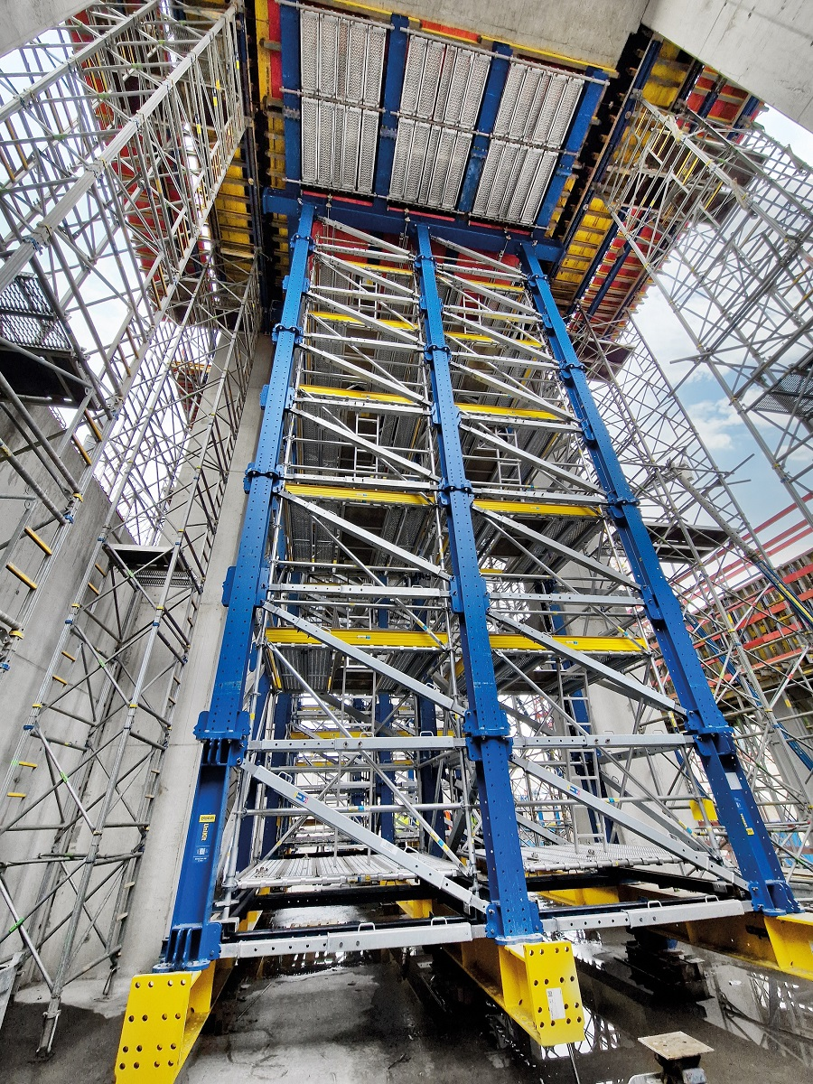

Doka UniKit – Doka’s engineering kit for complex infrastructure and industrial applications. © Doka

Ein Bild, das Eisenbahn, Bahn, Himmel, draußen enthält.

Doka UniKit in action – on a railway overpass in Austria. © Doka

Ein Bild, das draußen, Baum, Himmel, Brücke enthält.

Edge Beam Formwork NG for infrastructure and construction applications. © Doka

Ein Bild, das Turm enthält.

DokaXshore for construction and renovation of the bridges. © Doka

**About Doka**

Doka is a world leader in innovative formwork and scaffolding solutions for construction. With more than 180 sales and logistics facilities in over 58 countries, Doka has a highly skilled, global team that delivers advice, engineering, customer service, and technical support for even the largest and most complex projects. The company's sophisticated distribution network ensures world-class service for customers wherever they work – from the largest cities to the most rural jobsites. Doka employs more than 9,000 people worldwide and is a company of the Umdasch Group, which has stood for reliability, experience, and trustworthiness for more than 150 years.

****

**Media contact**

Claire Combs

Director of Communications  
North America and Latin America **M** +1 918 998 3333

[claire.combs@doka.com](mailto:claire.combs@doka.com) | [www.doka.com](http://www.doka.com)